CSA1708-ARTIFICIAL INTELLIGENCE
LAB EXPERIMENTS
Program 3: Python program to water jug problem
Aim:
To write a Python program to solve the Water Jug Problem using the Breadth-First Search (BFS) algorithm and obtain the required amount of water.
Algorithm
- Start with both jugs empty.
- Represent the state as (A, B), where A and B are the amounts of water in the 4L and 3L jugs.
- Perform possible operations: fill, empty, and transfer water between the jugs.
- Store each new state and avoid repeated states.
- Continue until the required 2 litres is obtained.
- Display the sequence of states and the final result.
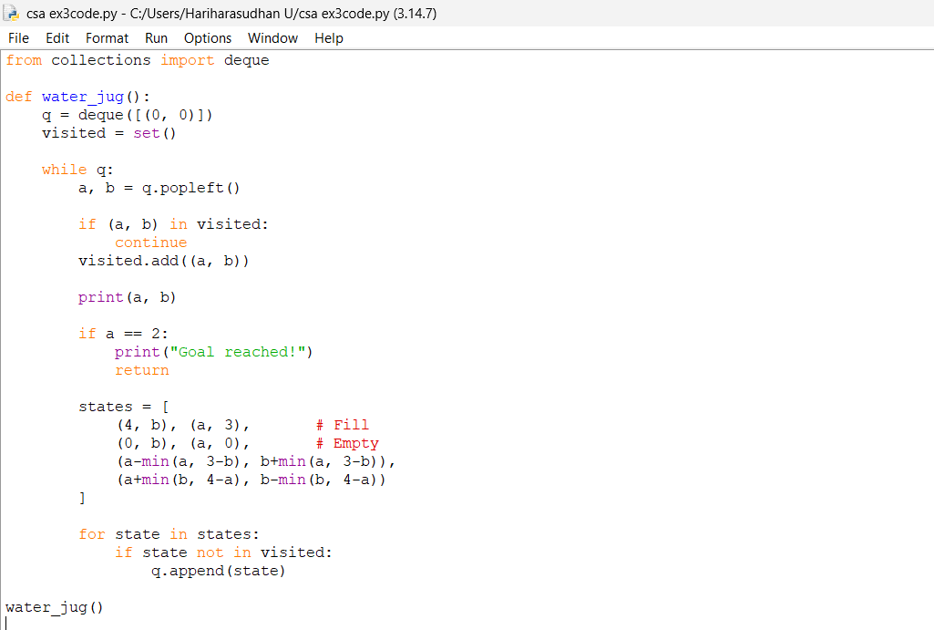
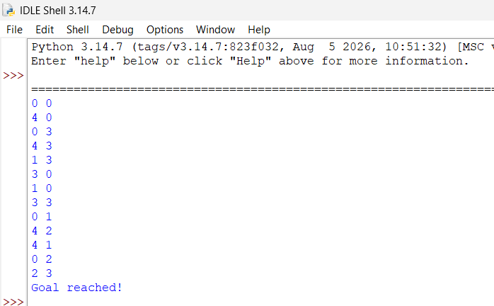
Result
Thus, the Water Jug Problem was successfully solved using Python, and the required 2 litres of water was obtained using the 4-litre and 3-litre jugs.

